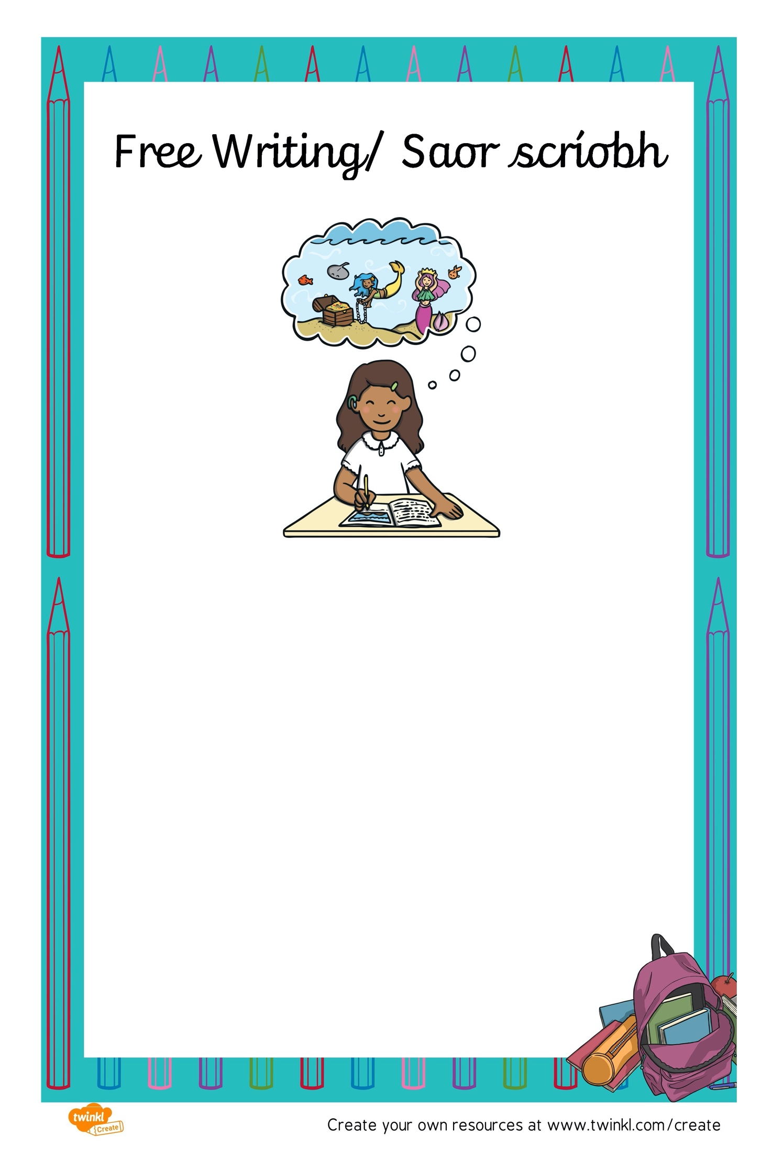

An féidir libh scéal, dán, amhrán nó leabhar grinn a chumadh an tseachtain seo? Úsáid do shamhlaíocht….. clóscríobh é nó glac grianghraf agus seol é ar aghaidh chuig Múinteoir Leah – [leah@gaelscoilbhailemunna.ie](mailto:leah@gaelscoilbhailemunna.ie)

Rachaidh cuid acu suas ar an suíomh scoile, bí ag faire amach!

Can you write a story, poem, song or comic this week? Use your imagination….type it or take a photograph and send it on to Múinteoir Leah – [leah@gaelscoilbhailemunna.ie](mailto:leah@gaelscoilbhailemunna.ie)

Some of them will go up on the school website, keep your eye out for them!