Chaos at Easter

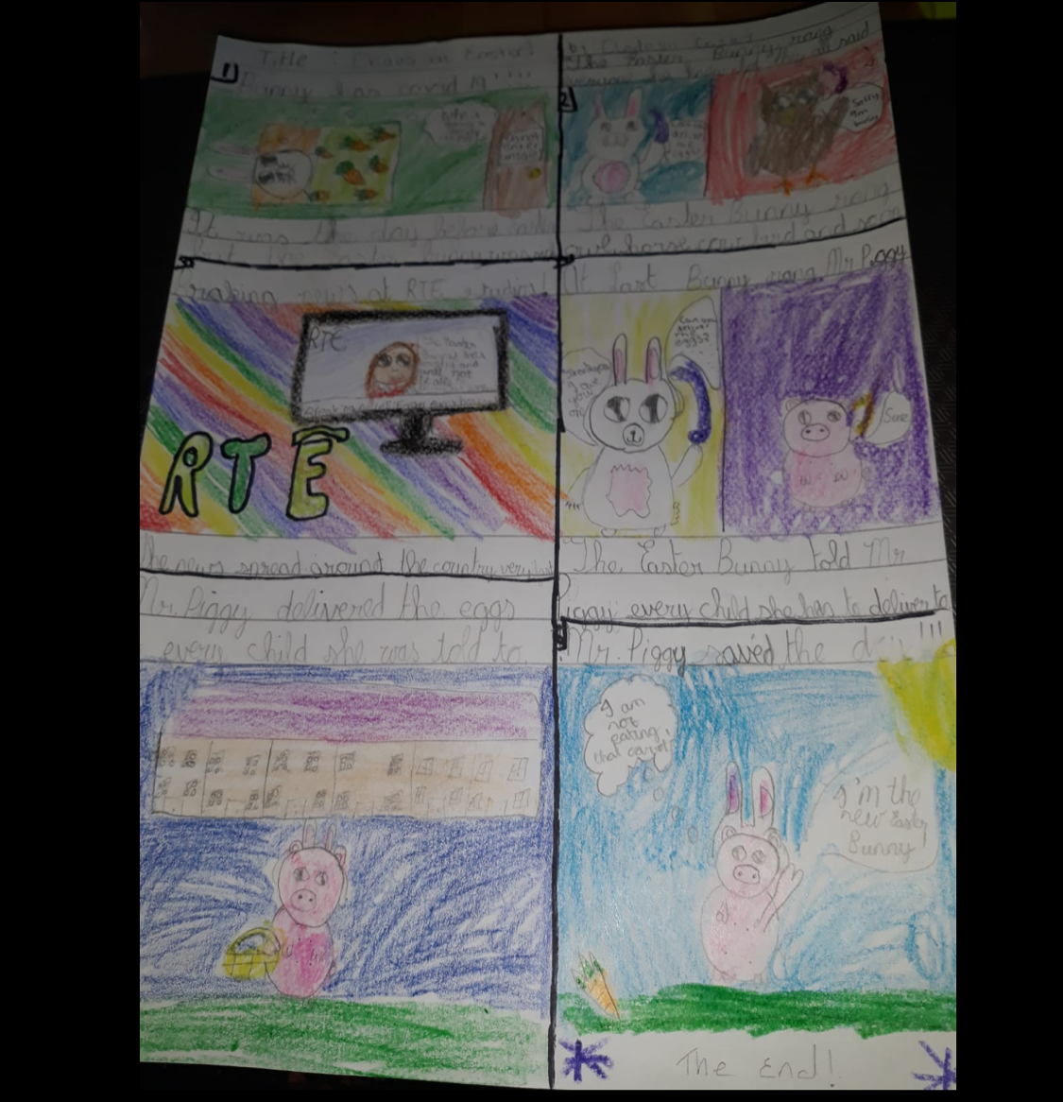

Box 1.
BUNNY HAS COVID 19 !!! :(
It was the day before Easter but the Easter Bunny was sick.
Box 2
The Easter Bunny phoned everyone he knew to ask if they could deliver the Easter eggs , But they all said "sorry I am busy"
Box 3
BREAKING NEWS AT RTE STUDIOS!!!!!
" The Easter Bunny has Covid 19 and will not be able to deliver the Easter eggs!"
The news spread around the country very fast.
Box 4
At last Bunny rang Mr Piggy . He asked " can you deliver the Easter eggs?" "Sure" said Mr Piggy.
The Easter Bunny told Mr Piggy , every child she has to deliver to.
Box 5
Mr Piggy delivered the eggs to every child she was told to.
Box 6
Mr Piggy saved the day!!! :)
The End

