The Greedy thief

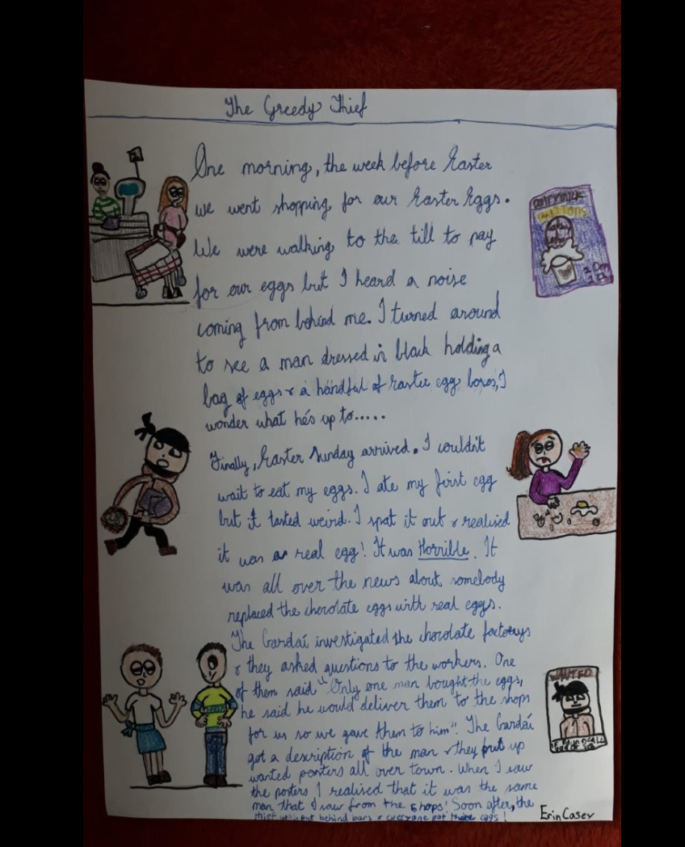

One morning, the week before Easter we went shopping for our Easter eggs. We were walking to the till to pay for our eggs but I heard a noise coming from behind me.
I turned around to see a man dressed in black. He was holding a bag of eggs and a handful of Easter egg boxes. " I wonder what he is up to? ....." I thought.
Finally, Easter Sunday arrived. I couldn’t wait to eat my eggs. I ate my first egg but it tasted weird!!! I spat it out and realised it was a real egg. It was horrible. It was all over the news about how somebody had replaced the chocolate eggs with real eggs.
The Gardai investigated the chocolate factories and they asked questions to the workers. One of them said " only one man bought all the eggs, he said he would deliver them to all the shops for us, so we gave him all the eggs."
The Gardai got a description of the man and they put up wanted posters all over town. When I saw the posters I realised that it was the same man that was in the shops!! Soon after the thief was put behind bars and everyone got their Chocolate eggs :)
The End.
Erin Casey

