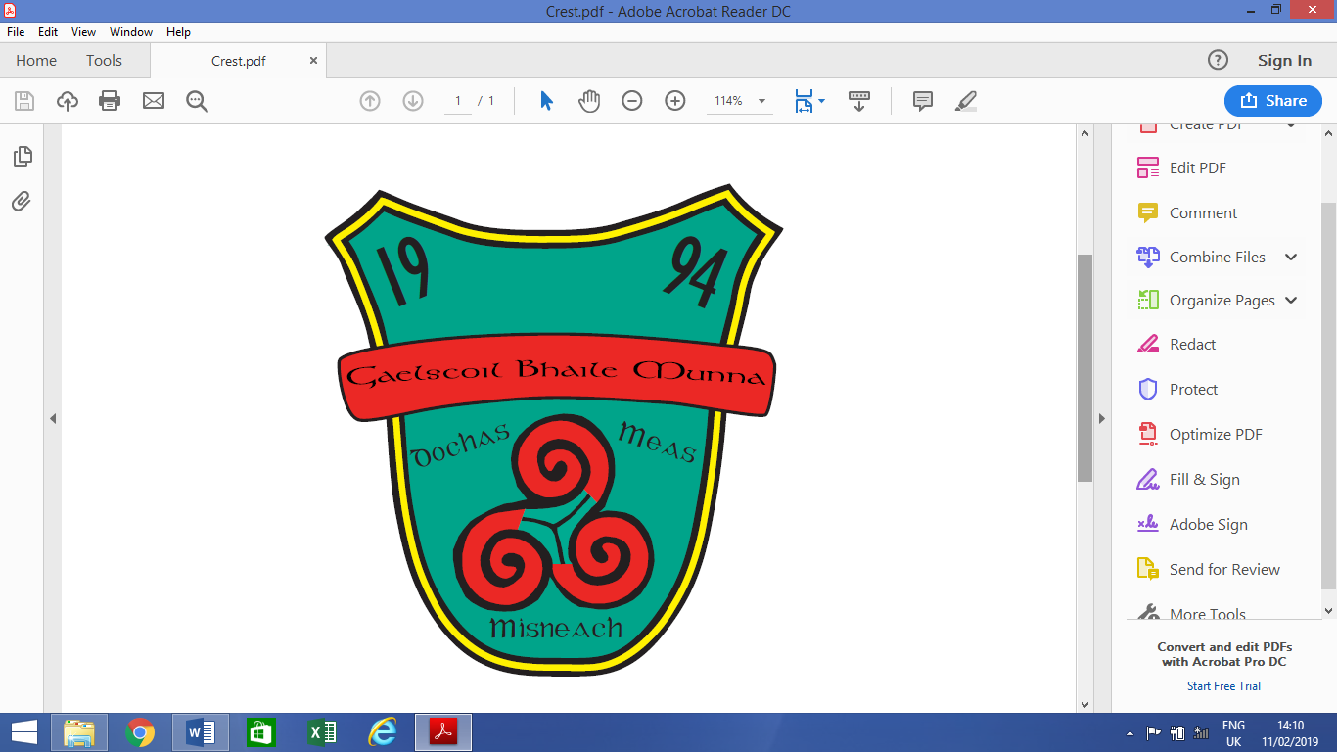

**Admission Policy 2024/25**

**Gaelscoil Bhaile Munna**

**Coultry Road, Ballymun, Dublin 9, D09TY74**

**20015B**

**School Patron: An Foras Pátrúnachta**

## **Introduction**

This Admission Policy complies with the requirements of the Education Act 1998, the Education (Admission to Schools) Act 2018 and the Equal Status Act 2000. In drafting this policy, the board of management of the school has consulted with school staff, the school patron and with parents of children attending the school.

This policy is published on the school’s website and will be made available in hardcopy, on request, to any person who requests it.

The relevant dates and timelines for Gaelscoil Bhaile Munna admission process are set out in the school’s annual admission notice which is published annually on the school’s website at least one week before the commencement of the admission process for the school year concerned.

This policy must be read in conjunction with the annual admission notice for the school year concerned.

The application form for admission is published on the school’s website and will be made available in hardcopy on request to any person who requests it.

The Irish language version of this policy will take precedence in the case of a discrepancy.

## **Characteristic spirit and general objectives of the school**

Gaelscoil Bhaile Munna is an all-Irish primary school under An Foras Pátrúnachta. It is a co-educational school established in 1994 and has a catholic ethos.

The promotion of Irish is a primary objective of the school. We welcome all children regardless of their background, beliefs or special needs.

With the establishment of Gaelscoil Bhaile Munna, it was our aim to ensure that every pupil, parent and teacher had an enjoyable and enriching time at our school. We aim to achieve an enjoyable and happy environment through the corner stone of cooperation and understanding.

The school aspires to achieve the wholistic development of the child. Much emphasis is placed on social and personal development of pupils. The school crest is based on this ideal and has the words hope, respect and courage written on it. Our school strives to deliver a high standard of education through the medium of Gaeilge while also preparing pupils for their future.

Every effort is made to create a pleasant Irish environment where pupils learn to respect and appreciate their own culture and also the cultures of others.

It is the responsibility of all within our school to ensure that there exists an environment of calm, fairness and safety for all.

## **Admission Statement**

Gaelscoil Bhaile Munna will not discriminate in its admission of a student to the school on any of the following:

1. the gender ground of the student or the applicant in respect of the student concerned,
2. the civil status ground of the student or the applicant in respect of the student concerned,
3. the family status ground of the student or the applicant in respect of the student concerned,
4. the sexual orientation ground of the student or the applicant in respect of the student concerned,
5. the religion ground of the student or the applicant in respect of the student concerned,
6. the disability ground of the student or the applicant in respect of the student concerned,
7. the ground of race of the student or the applicant in respect of the student concerned,
8. the Traveller community ground of the student or the applicant in respect of the student concerned, or
9. the ground that the student or the applicant in respect of the student concerned has special educational needs

As per section 61 (3) of the Education Act 1998, ‘civil status ground’, ‘disability ground’, ‘discriminate’, ‘family status ground’, ‘gender ground’, ‘ground of race’, ‘religion ground’, ‘sexual orientation ground’ and ‘Traveller community ground’ shall be construed in accordance with section 3 of the Equal Status Act 2000.

Gaelscoil Bhaile Munna is a school which has established one special class, with the approval of the Minister for Education and Skills, which provides an education exclusively for students with a diagnosis of Autism Spectrum Disorder (ASD) and may refuse to admit to the class a student who does not have the category of needs specified. This class functions through the medium of Irish and English.

**4. Categories of Special Educational Needs catered for in the school/special class**

Gaelscoil Bhaile Munna with the approval of the Minister for Education and Skills, has established an ASD class to provide an education exclusively for students with;  
1. A diagnosis of Autism.

2. A clear stated recommendation for placement in an ASD-specific class setting.

1. **Admission of Students**

This school shall admit each student seeking admission except where –

1. the school is oversubscribed.
2. a parent of a student, when required by the principal in accordance with section 23(4) of the Education (Welfare) Act 2000, fails to confirm in writing that the code of behaviour of the school is acceptable to him or her and that he or she shall make all reasonable efforts to ensure compliance with such code by the student.
3. The ASD specific class attached to Gaelscoil Bhaile Munna provides an education exclusively for students with a diagnosis of Autism and the school may refuse admission to this class, where the student concerned does not have the specified category of special educational needs provided for in this class.

## **Oversubscription**

In the event that the school is oversubscribed, the school will, when deciding on applications for admission, apply the following selection criteria **in the order listed below to those applications that are received within the timeline for receipt of applications as set out in the school’s annual admission notice**:

|  |
| --- |
| 1. Brothers, sisters, half-siblings, foster children or adopted children of current pupils. 2. Children who have attained a determined level of fluency in Irish which would be likely to decline if he / she is not admitted to an all-Irish school. * 3. According to age; the oldest child first.   **\* The onus will be on parents / guardians to provide sufficient evidence to demonstrate to the board the required level of fluency in Irish. See further information in the relevant document available from the school.**  In the case of enrolment in our special class, please note criteria in order below.  All applicants must have a report stating diagnosis of ASD **and** have a recommendation for a place in a special class.  Students who are already in a mainstream class in Gaelscoil Bhaile Munna.  Pupils of Junior or senior infants age to assist with early intervention.  Brothers, sisters, half-siblings, foster children or adopted children of current pupils. |

In the event that there are two or more students tied for a place or places in any of the selection criteria categories above (the number of applicants exceeds the number of remaining places), the following arrangements will apply:

|  |
| --- |
| The school Board reserves the right to set the maximum number of pupils in any given class. The maximum number of pupils to be admitted in Junior Infants shall be 24.  If two or more pupils are tied under criteria 1/2, priority will be set according to the next criterion on the list. If criterion 3 applies, the time of birth available on the birth certificate will be taken into account. |

## **What will not be considered or taken into account**

In accordance with section 62(7)(e) of the Education Act, the school will not consider or take into account any of the following in deciding on applications for admission or when placing a student on a waiting list for admission to the school:

|  |
| --- |
| 1. a student’s prior attendance at a pre-school or pre-school service, including naíonraí. 2. the payment of fees or contributions (howsoever described) to the school; 3. a student’s academic ability, skills or aptitude;   other than in relation to:  admission to an Irish language school, in accordance with the provisions of section 62(9) of the act   1. the occupation, financial status, academic ability, skills or aptitude of a student’s parents; 2. a requirement that a student, or his or her parents, attend an interview, open day or other meeting as a condition of admission; 3. a student’s connection to the school by virtue of a member of his or her family attending or having previously attended the school;   other than in the case of the school wishing to include a selection criteria based on siblings of a student attending or having attended the school.   1. the date and time on which an application for admission was received by the school,   This is subject to the application being received at any time during the period specified for receiving applications set out in the annual admission notice of the school for the school year concerned.  This is also subject to the school making offers based on existing waiting lists (up until 31st January 2025 only). |

## **Decisions on applications**

All decisions on applications for admission to Gaelscoil Bhaile Munna will be based on the following:

* Our school’s admission policy
* The school’s annual admission notice (where applicable)
* The information provided by the applicant in the school’s official application form received during the period specified in our annual admission notice for receiving applications

(Please see section 13 below in relation to applications received outside of the admissions period and section 14 below in relation to applications for places in years other than the intake group.)

Selection criteria that are not included in our school admission policy will not be used to make a decision on an application for a place in our school.

## **Notifying applicants of decisions**

Applicants will be informed in writing as to the decision of the school, within the timeline outlined in the annual admissions notice.

If a student is not offered a place in our school, the reasons why they were not offered a place will be communicated in writing to the applicant, including, where applicable, details of the student’s ranking against the selection criteria and details of the student’s place on the waiting list for the school year concerned.

Applicants will be informed of the right to seek a review/right of appeal of the school’s decision (see section 17 below for further details).

## **Acceptance of an offer of a place by an applicant**

In accepting an offer of admission from Gaelscoil Bhaile Munna you must indicate —

(i) whether or not you have accepted an offer of admission for another school or schools. If you have accepted such an offer, you must also provide details of the offer or offers concerned and

(ii) whether or not you have applied for and awaiting confirmation of an offer of admission from another school or schools, and if so, you must provide details of the other school or schools concerned.

## **Circumstances in which offers may not be made or may be withdrawn**

An offer of admission may not be made or may be withdrawn by Gaelscoil Bhaile Munna where —

1. it is established that information contained in the application is false or misleading.
2. an applicant fails to confirm acceptance of an offer of admission on or before the date set out in the annual admission notice of the school.
3. the parent of a student, when required by the principal in accordance with section 23(4) of the Education (Welfare) Act 2000, fails to confirm in writing that the code of behaviour of the school is acceptable to him or her and that he or she shall make all reasonable efforts to ensure compliance with such code by the student; or
4. an applicant has failed to comply with the requirements of ‘acceptance of an offer’ as set out in section 9 above.

## **Sharing of Data with other schools**

Applicants should be aware that section 66(6) of the Education (Admission to Schools) Act 2018 allows for the sharing of certain information between schools in order to facilitate the efficient admission of students.

**Section 66(6) allows a school to provide a patron or another board of management with a list of the students in relation to whom —**

(i) an application for admission to the school has been received,

(ii) an offer of admission to the school has been made, or

(iii) an offer of admission to the school has been accepted.

**The list may include any or all of the following:**

(i) the date on which an application for admission was received by the school;

(ii) the date on which an offer of admission was made by the school;

(iii) the date on which an offer of admission was accepted by an applicant;

(iv) a student’s personal details including his or her name, address, date of birth and personal public service number (within the meaning of section 262 of the Social Welfare Consolidation Act 2005).

## **Waiting list in the event of oversubscription**

In the event of there being more applications to the school year concerned than places available, a waiting list of students whose applications for admission to Gaelscoil Bhaile Munna were unsuccessful due to the school being oversubscribed will be compiled and will remain valid for the school year in which admission is being sought.

Placement on the waiting list of Gaelscoil Bhaile Munna is in the order of priority assigned to the students’ applications after the school has applied the selection criteria in accordance with this admission policy.

Offers of any subsequent places that become available for and during the school year in relation to which admission is being sought will be made to those students on the waiting list, in accordance with the order of priority in relation to which the students have been placed on the list.

## **Late Applications**

A place will be offered if a place is available in the school.

If there is an over-subscription for places at the school following the main admissions process, any school place that subsequently emerges from the waiting list created from that process will be filled.

If applications are received after the closing date as set out in the Annual Admission Notice a supplementary waiting list will be created. The main waiting list will be cleared before candidates are offered places on this supplementary list. When a space becomes available in the school, applications for the supplementary waiting list will be considered against the selection criteria in this admissions policy on the day that that place becomes available in accordance with the School Admissions Act 2018 and in accordance with any regulations made under that Act.

## **Procedures for admission of students to other years and during the school year**

|  |
| --- |
| The procedures of the school in relation to the admission of students who are not already admitted to the school to classes or years **other than the school’s intake group** are as follows:  Parents/guardians wishing to apply for a place in any class other than Junior Infants must write an application letter to this effect to the Chairperson of the Board. The decision to accept children in any other class is a matter for the Board of Management to decide.  **Senior Infants / 1st Class**  Places will be allocated if places are available in the following classes: Senior Infants and 1st Class. Where the number of applications exceeds the number of places available in the relevant class, the school will apply the selection criteria set out in Section 6 of this policy applies to such applications. Where no places are available, the child's name will be placed on the waiting list in accordance with Section 12 of this policy.  **2nd to 6th Class**  Children in 2nd to 6th class will be given a place if there is space in the class **and** the Principal / Board of Management decides that the child's Irish language ability is at a level that would allow the child to function and learn in class and where other pupils would not have to turn to English to communicate. **The parent/guardian will be required to provide evidence of this standard.** The Board of Management will have the final decision in these cases. |

|  |
| --- |
| The procedures of the school in relation to the admission of students who are not already admitted to the school, after the commencement of the school year in which admission is sought, are as follows:  Parents / guardians wishing to apply for a place in any class other than Junior Infants must write an application letter to this effect to the Chairperson of the Board. The decision to accept children in any other class is a matter for the Board of Management to decide.  **Senior Infants / 1st Class**  Places will be allocated if places are available in the following classes: Senior Infants and 1st Class. Where the number of applications exceeds the number of places available in the relevant class, the school will apply the selection criteria set out in Section 6 of this policy applies to such applications. Where no places are available, the child's name will be placed on the waiting list in accordance with Section 12 of this policy.  **2nd to 6th Class**  Children in 2nd to 6th class will be given a place if there is space in the class **and** the Principal / Board of Management decides that the child's Irish language ability is at a level that would allow the child to function and learn in class and where other pupils would not have to turn to English to communicate. **The parent / guardian will be required to provide evidence of this standard.** The Board of Management will have the final decision in these cases. |

## **Declaration in relation to the non-charging of fees**

This rule applies to all schools.

The board of Gaelscoil Bhaile Munna or any persons acting on its behalf will not charge fees for or seek payment or contributions (howsoever described) as a condition of-

1. an application for admission of a student to the school, or
2. the admission or continued enrolment of a student in the school.

## **Arrangements regarding students not attending religious instruction**

|  |
| --- |
| Our school welcomes all pupils. Religious instruction is a part of the school day and children are prepared for the sacraments.  If a student does not wish to be part of the religious instruction class or prepare for sacraments, alternative individual work will be assigned to that student. He / She will remain in the classroom during the lessons however will not be required to partake in the class for the duration of the lessons. |

## **Reviews/appeals**

**Review of decisions by the board of Management**

The parent of the student, or in the case of a student who has reached the age of 18 years, the student, may request the board to review a decision to refuse admission. Such requests must be made in accordance with Section 29C of the Education Act 1998.

The timeline within which such a review must be requested and the other requirements applicable to such reviews are set out in the procedures determined by the Minister under section 29B of the Education Act 1998 which are published on the website of the Department of Education and Skills.

The board will conduct such reviews in accordance with the requirements of the procedures determined under Section 29B and with section 29C of the Education Act 1998.

**Note:** Where an applicant has been refused admission due to the school being oversubscribed, the applicant **must request a review** of that decision by the board of management prior to making an appeal under section 29 of the Education Act 1998.

Where an applicant has been refused admission due to a reason other than the school being oversubscribed, the applicant **may request a review** of that decision by the board of management prior to making an appeal under section 29 of the Education Act 1998.

**Right of appeal**

Under Section 29 of the Education Act 1998, the parent of the student, or in the case of a student who has reached the age of 18 years, the student, may appeal a decision of this school to refuse admission.

An appeal may be made under Section 29 (1)(c)(i) of the Education Act 1998 where the refusal to admit was due to the school being oversubscribed.

An appeal may be made under Section 29 (1)(c)(ii) of the Education Act 1998 where the refusal to admit was due a reason other than the school being oversubscribed.

Where an applicant has been refused admission due to the school being oversubscribed, the applicant **must request a review** of that decision by the board of management **prior to making an appeal** under section 29 of the Education Act 1998. (see Review of decisions by the Board of Management)

Where an applicant has been refused admission due to a reason other than the school being oversubscribed, the applicant **may request a review** of that decision by the board of management prior to making an appeal under section 29 of the Education Act 1998. (see Review of decisions by the Board of Management)

Appeals under Section 29 of the Education Act 1998 will be considered and determined by an independent appeals committee appointed by the Minister for Education and Skills.

The timeline within which such an appeal must be made and the other requirements applicable to such appeals are set out in the procedures determined by the Minister under section 29B of the Education Act 1998 which are published on the website of the Department of Education and Skills.

Pádraig B. Mac Criostail Chairperson, Board of Management