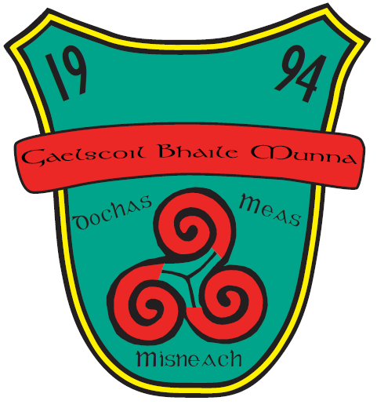

School Bí Cineálta Policy to Prevent and Address Bullying Behaviour

Bí Cineálta Policy to Prevent and Address Bullying Behaviour

The Board of Management of Gaelscoil Bhaile Munna has adopted the following policy to prevent and address bullying behaviour.
This policy fully complies with the requirements of Bí Cineálta: Procedures to Prevent and Address Bullying Behaviour for Primary and Post-Primary Schools 2024.
The board of management acknowledges that bullying behaviour interferes with the rights of the child as set out in the United Nations Convention on the Rights of the Child. We all, as a school community, have a responsibility to work together to prevent and address bullying behaviour and to deal with the negative impact of bullying behaviour.
We are committed to ensuring that all students who attend our school are kept safe from harm and that the wellbeing of our students is at the forefront of everything that we do. We recognise the negative impact that bullying behaviour can have on the lives of our students and we are fully committed to preventing and addressing bullying behaviour.
We confirm that we will, in accordance with our obligations under equality legislation, take all such steps that are reasonably practicable to prevent the harassment of students or staﬀ on any of the nine grounds specified: gender, civil status, family status, sexual orientation, religion, age, disability, race and membership of the Traveller community.

Definition of bullying
Bullying is defined in Cineáltas: Action Plan on Bullying and Bí Cineálta: Procedures to Prevent and Address Bullying Behaviour for Primary and Post-Primary Schools as targeted behaviour, online or oﬄine that causes harm. The harm caused can be physical, social and/or emotional in nature. Bullying behaviour is repeated over time and involves an imbalance of power in relationships between two people or groups of people in society. The detailed definition is provided in Chapter 2 of the Bí Cineálta procedures.
Each school is required to develop and implement a Bí Cineálta policy that sets out how the school community prevents and addresses bullying behaviour. Strategies to deal with inappropriate behaviour that is not bullying behaviour are provided for within the school’s Code of Behaviour.

Section A: Development/review of our Bí Cineálta policy to prevent and address bullying behaviour
All members of our school community were provided with the opportunity to input into the development/review of this policy.

 | Date consulted | Method of consultation
School Staﬀ | 22/01/2025  28/03/2025 | Bí Cineálta training  Staff meeting, half-day school closure
Students | April 2025 | Questionnaires Rang 3-6
Parents | Term 3 2025 | Questionnaires sent to every family
Board of Management | 26/05/2025 | BOM meeting  CPSMA Vimeo
Wider school community as appropriate, for example, bus drivers
Date policy was approved: 16/06/2025
Date policy was last reviewed:

Section B: Preventing Bullying Behaviour

This section sets out the prevention strategies that will be used by the school. These include strategies specifically aimed at preventing online bullying behaviour, homophobic and transphobic bullying behaviour, racist bullying behaviour, sexist bullying behaviour and sexual harassment as appropriate (see Chapter 5 of the Bí Cineálta procedures):
Restorative Practice
SPHE
Friends for Life
Social and Emotional small groups
Roots of Empathy Programme
Incredible Years Programme
Online safety: Webwise, talks by outside agencies: Monica Rowe (Key Conversations)

The school has the following supervision and monitoring policies in place to prevent and address bullying behaviour (see Chapter 5 of the Bí Cineálta procedures):
Code of Behaviour
Child Protection
Child Safeguarding Statement
Procedures relating to school tours, swimming, supervision of students
Procedures relating to extra-curricular activities
Special Education Provision
Acceptable Usage Policy
Health & Safety
Intimate Care

Section C: Addressing Bullying Behaviour
The teacher(s) with responsibility for addressing bullying behaviour is (are) as follows:

When bullying behaviour occurs, the school will:
- ensure that the student experiencing bullying behaviour is heard and reassured
- seek to ensure the privacy of those involved
- conduct all conversations with sensitivity
- consider the age and ability of those involved
- listen to the views of the student who is experiencing the bullying behaviour as to how best to address the situation
- take action in a timely manner
- inform parents of those involved

The steps that will be taken by the school to determine if bullying behaviour has occurred, the approaches taken to address the bullying behaviour and to review progress are as follows (see Chapter 6 of the Bí Cineálta procedures):
- Principal/ Deputy principal will be made aware.
- We will speak to the student who may be/ have been the victim of bullying.
- We will ask the student what they feel should happen next, in their opinion depending on the age and ability of the student.
- We will devise a plan together, if it is appropriate to do so.
- We will speak to the child’s parents/ guardians.
- We will speak to the child/ children who has been found to have been involved in bullying behaviour and explain that this behaviour is not acceptable or appropriate.
- We will speak to the parents/ guardians of the child/ children.
- We will offer support to everyone involved to ensure that they feel happy and safe in our school.

The school will use the following approaches to support those who experience, witness and display bullying behaviour (see Chapter 6 of the Bí Cineálta procedures):
Class teacher or support teacher will speak to the child/ children individually.
The class teacher or support teacher will ensure that this conversation takes place in quiet place to ensure privacy for the student/ students.
Time and space will be given to the child/ children.
Restorative practice will be used as a way of gaining information and helping children to understand the impact of what has/ is happening. The children may answer the 5 restorative questions verbally or in writing, where appropriate.

Procedures to Prevent and Address Bullying Behaviour for Primary and Post­Primary Schools

All bullying behaviour will be recorded. This will include the type of behaviour, where and when it took place, and the date of the engagement with students and parents. The actions and supports agreed to address bullying behaviour will be documented. If the bullying behaviour is a child protection concern the matter will be addressed without delay in accordance with Child Protection Procedures for Primary and Post-Primary Schools.

Section D: Oversight
The principal will present an update on bullying behaviour at each board of management meeting. This update will include the number of incidents of bullying behaviour that have been reported since the last meeting, the number of ongoing incidents and the total number of incidents since the beginning of the school year. Where incidents of bullying behaviour have occurred, the principal will also provide a verbal update which will include where relevant, information relating to trends and patterns identified, strategies used to address the bullying behaviour and any wider strategies to prevent and address bullying behaviour where relevant. This update does not contain personal or identifying information. See Chapter 7 of the Bí Cineálta procedures.
This policy is available to our school community on the school’s website and in hard copy on request. A student friendly version of this policy is displayed in the school and is also available on our website and in hard copy on request.
This policy and its implementation will be reviewed, following input from our school community, each calendar year or as soon as practicable after there has been a material change in any matter to which this policy refers.

Signed: 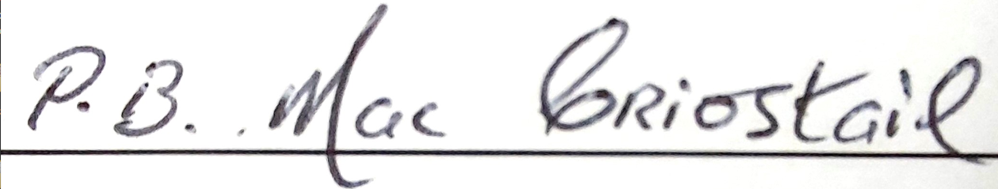 Date: 16/06/2025
(Chairperson of board of management)
Signed: 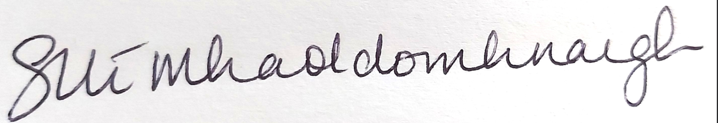 Date: 16/06/2025
(Principal)

