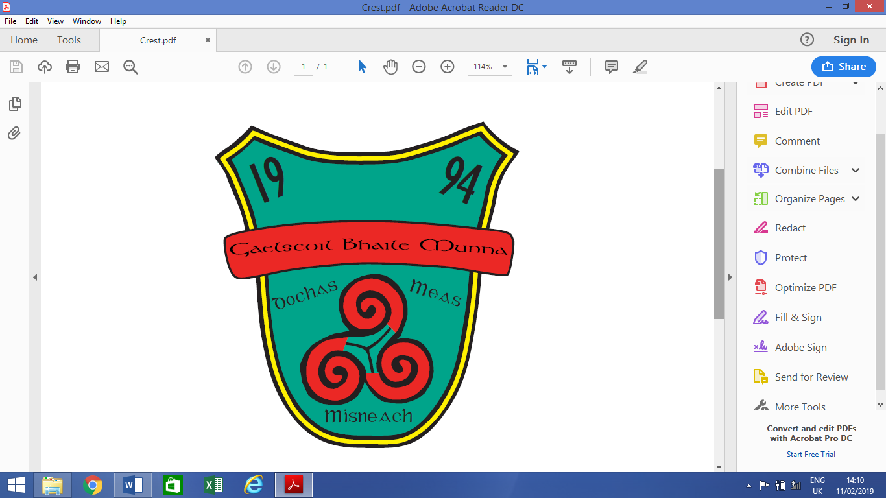

**ANNUAL ADMISSION NOTICE**

**in respect of admissions to the 2025/2026 school year**

**Admission Policy and Application Form**

A copy of the school’s **Admission Policy** and the **Application Form for Admission** for 2025/2026 is available as follows: –

To download at: www.gaelscoilbhailemunna.ie

On request: By emailing eolas@gaelscoilbhailemunna.ie or writing to: Gaelscoil Bhaile Munna, Bóthar Choltraí, Baile Munna, D09TY74 or in person from the school office.

**PART 1 - Admissions to the 2025/2026 school year**

**Application and Decision Dates for admission to Gaelscoil Bhaile Munna 2025/2026**

**The following are the dates applicable for admission to Junior Infants:**

|  |  |
| --- | --- |
| The school will commence accepting applications for admission on | **01/10/2024** |
| The school shall cease accepting applications for admission on | **22/10/2024** |
| The date by which applicants will be notified of the decision on their application is | **12/11/2024** |
| The period within which applicants must confirm acceptance of an offer of admission is | **26/11/2024** |

**Note: the school will consider and issue decisions on late applications in accordance with the school’s admission policy.**

**\*Failure to accept an offer within the prescribed period above may result in the offer being withdrawn.**

**Number of places being made available in Junior Infants 2025/2026**

|  |  |
| --- | --- |
| The number of places being made available in junior infants | **24** |
| The number of places available in our special class | **0** |